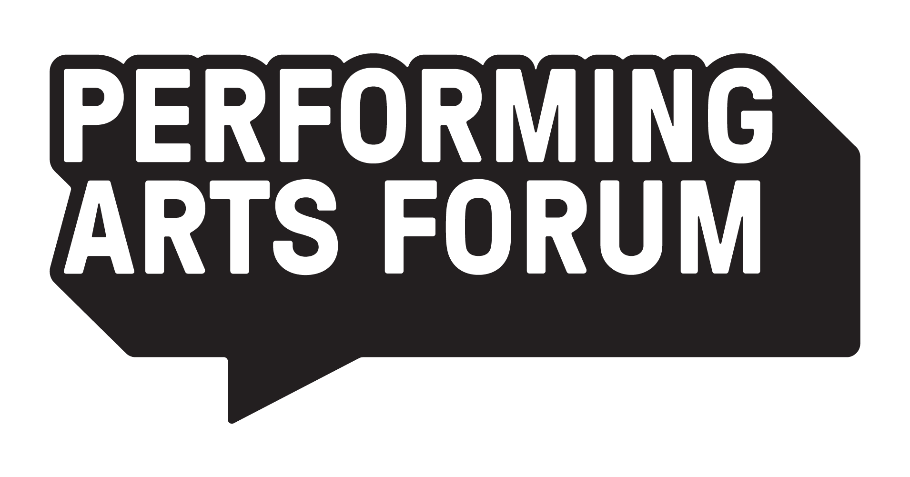

COMMISSIONING A NEW PLAY // SAMPLE CONTRACT

info@performingartsforum.ie
+353 1 677 8779
www.performingartsforum.ie



It is important to stress that this sample Author’s agreement is not designed for any specific set of circumstances and hence if it is being used by a Performing Arts Forum member it may have to be adapted in an appropriate manner, based on professional legal advice if necessary.
What follows is a list of the terms and conditions that best represent current industry standards. These terms and conditions may need to be amended, however, depending on the particular artistic and financial circumstances of the production and the company’s size and level of funding.

Memorandum of Agreement
made the [#] day of [#] 20[#]
Between
[Author] of [Production Title], hereinafter called “The Author”, of the one part

And
[Producer] of [Production Title], hereinafter called “The Producer”, which expression shall include its successors in title and assigns

Whereas
1. The Producer wishes to commission the Author to write a play in the English language, hereinafter referred to as “the Play,” and to secure a licence to produce and perform the Play on the professional stage in live performance in the Republic of Ireland
And
2. The Author undertakes to write the Play of which the Author shall be the sole owner of the copyright including the dramatic rights and shall have full power to grant the licence herein contained
3. The Author hereby covenants, warrants and undertakes that:
  - the Play shall contain no defamatory, obscene or otherwise unlawful matter;
  - they agree to keep the Company fully indemnified from and against any losses, costs, actions, proceedings, claims, damages, expenses or liabilities suffered or incurred directly or indirectly by the Company in consequence of any breach, or non-observance by the Author of any of his/her agreements, conditions, obligations, representations, warranties and undertakings. The Author hereby expressly acknowledges that this indemnity shall survive the completion of the Author’s services hereunder.
  - the Company shall indemnify the Author from all third-party claims, liabilities, damages, costs and reasonable legal fees arising from any breach by the Company of any warranty or agreement made by the Company or from any use of the rights granted and /or services rendered by the Company hereunder. The Company hereby expressly acknowledges that this indemnity shall survive the completion of the Company’s services hereunder.

Now it is Hereby Mutually Agreed as follows:
1. In consideration of the covenants and conditions on the part of the Producer hereinafter contained and payment of an advance sum of [€], on account of royalties but non-returnable in any event, in accordance with the following schedule: [€] on signature of this agreement and [€] on delivery of the first draft on or before [date], the Author hereby grants to the Producer the exclusive right of presentation of the Play in the English language on the professional stage at the [name of theatre] Theatre, and thereafter in the Republic of Ireland for a period of [#] calendar months from the date of this agreement.
2. If the Producer fails to produce the Play within the period specified and as provided for in Clause 1 above then all rights in the Play shall revert to the Author.
3. If the Producer produces the Play or causes same to have been produced in the English language on the professional stage at the [name of theatre] Theatre within the period specified in Clause 1 and provided that not less than [#] performances, including previews, have been given and paid for, the Author hereby grants to the Producer an exclusive licence of the dramatic rights in the Play in the English language on the professional stage in the Republic of Ireland for a period of [#] years from the date of the first performance of the Play of its premiere run. Should the Producer fail during the said period of [#] years either to give a minimum of [#] performances including previews in any one-year period commencing on the first anniversary of the first performance of the Play of its premiere run, or to pay an additional non-returnable advance against royalties of [€] in any such one-year period, then all rights hereby granted in the Play shall thereupon revert to the Author.
4. Subject to the Producer having presented and paid for a minimum of [#] performances, including previews, within the period stipulated as provided for in Clause 1 and the Author approving the production, the Author hereby grants to the Producer the sole and separate options in the United Kingdom, including West End of London, the United States of America and The Rest of the English Speaking World exercisable in each case by payment and written notice to the Author at any time on or before the expiry of [#] months from the first performance of the Play of the premiere run at the [name of theatre] Theatre.
- Option 1: United Kingdom to include West End of London: by payment of [£] Pounds Sterling, being on account of royalties, but non-returnable in any event, to acquire the exclusive right to perform the Play or authorise its performance in the United Kingdom within a period of [#] months from the date of exercise of the option on terms and conditions to be negotiated in good faith, such terms in line with industry practice- including but not limited to provision for Producer’s lien on US rights.
- Option 2: United States of America:
  - to acquire New York Production rights - whereby New York Production shall mean on or off-Broadway - by payment of [$] US Dollars, on account of royalties, but non-returnable in any event, such terms to be negotiated in good faith but on terms and conditions no less favourable to the Author than those of the Dramatists’ Guild APC.
  - or subject to the Author’s approval - such approval not to be unreasonably withheld - to acquire the right to present the Play in a US production outside New York City, the US Production, by payment of [$] US Dollars, on account of royalties, but non-returnable in any event, on terms and conditions to be negotiated in good faith and in line with industry practice. The grant of rights outlined in this clause shall not include the grant of Broadway or off-Broadway rights - New York Production rights - but shall allow the Producer a lien on such rights, the acquisition of which shall be subject to further terms and conditions - including but not limited to payment of further advance sums and presentation of a number of qualifying performances.
- Option 3: Rest of the English-Speaking World: by payment of [€] euro, being on account of royalties, but non-returnable in any event, to acquire the exclusive right to perform the Play or authorise its performance in the Rest of the English-Speaking World within a period of [#] months from the date of exercise of the option on terms and conditions to be negotiated in good faith and in line with industry practice.
Notwithstanding the above, it is understood that the Producer shall not undertake to exercise any of the options without due consultation with the Author. The Producer shall not be able to complete any assignment, license or sublease of rights to any third party without the Author’s approvals and having paid for and concluded negotiation for such rights with the Author.
5. The Producer shall pay to the Author a total royalty of [ ] percent, of the gross box office receipts - defined as the sums actually received at the box office after the deduction of value added tax or any other tax levied thereon, credit card and charge card and other sales commissions; and group and other sales-stimulating discounts - on all performances of the premiere run of the Play at the [name of theatre] Theatre.
The royalty payable on future performances given by the Producer in the Republic of Ireland shall be subject to terms and conditions to be negotiated in good faith and in line with industry practice.
The royalty payable on future performances in the United Kingdom, United States of America and the Rest of the English-Speaking World may involve a reduction in the royalty rate and/or royalty pooling arrangements and will be subject to good faith negotiation in line with industry practice, as outlined in clause 4 above.
6. Certified returns for each performance of the Play hereunder shall be sent by the Producer to the Author through its authorised representative and the Producer shall make payment for all sums shown to be due to the Author no later than two weeks after the close of the premiere run at the [name of theatre] Theatre.
7. If the Producer produces the Play or causes same to have been produced in the English language on the professional stage at the [name of theatre] Theatre within the period specified in Clause 1 and provided that not less than [#] performances, including previews, have been given and paid for, the Author hereby grants to the Producer the sole and exclusive option during the period from the date hereof until [#] months after the first performance of the premiere run of the Play to acquire the Screen Rights in the Play - defined as all film and motion picture rights, all television, rights and all video/DVD rights throughout the world in all languages and all rights ancillary thereto including those now known and those to be invented - throughout the world on terms and conditions to be negotiated in good faith and in line with industry practice. Following this period, the Producer shall have the right, for a further [#] months, to match any other offer to acquire the Screen Rights in the Play.
During this period, the Author agrees not to license amateur performances of the Play without the prior written consent of the Producer; such consent not to be unreasonably withheld.
For the avoidance of doubt, should the Producer enter into a separate agreement to govern a West End production and/or production in the US Territory, such agreement will provide for a holdback on amateur and audio-visual rights the holdback period to be negotiated in good faith and in line with industry practice.
8. In the event that the Producer’s rights in any territory revert to the Author, and provided that not less than [#] performances - including previews - have been given and paid for in the relevant territory, the Producer will retain a right to [ ] percent of the Author’s royalty from productions in that territory for a period of [#] years and the Author will make best efforts to ensure that the Producer receives a credit in all programmes for productions which take place during that time, as follows: “originally produced by [name of Producer] at the [name of theatre] Theatre”.
9. The Producer agrees that in its production of the Play the Author shall have approval of the choice of director, actors and designers for the production, and any and all replacements thereof, such approval not to be unreasonably withheld. The Producer shall further keep the Author fully informed of the opening dates and shall supply press comments upon the performances of the Play. The Producer agrees to provide [#] pairs of complimentary tickets to the opening performance of each new production of the play.
10. The Producer agrees that on all posters, programmes and other usual paid advertising material in connection with its production of the Play, the Author shall receive prominent billing immediately beneath the title of the Play. No other name shall be larger than that of the Author, except stars who appear above the title.
11. The Author shall have approval of any biographies or photographs of the Author used, which approval shall not be unreasonably withheld; and, where practicable, the Author shall be consulted about all publicity and press material that comes directly under the control of the Producer.
12. The Producer shall be entitled to request that the Author participate, subject to the Author's prior professional commitments, in publicising the Play, including the giving of press and publicity interviews and the making of personal appearances with regard thereto.
13. The Author shall be entitled to attend rehearsals and previews of the Play.
14. [#] pairs of complimentary seats shall be made available by the Producer to the Author for the official opening night of the Play. Subject to the availability of seats, the Producer will also make available tickets for purchase by the Author provided that the Author informs the Producer of such request 24 hours prior to the performance for which tickets are required.
15. During the run of the Play the Producer shall be entitled to authorise excerpts from the Play to be televised for the purposes of publicity provided such excerpts shall not exceed [#] minutes duration in aggregate.
16. The Producer shall not make nor permit to be made any alterations to the Play in the definitive text as provided by the Author unless these changes have been previously approved in writing by the Author. Any change of any kind whatsoever in the manuscripts, stage business or performance of the Play made by anyone shall be deemed to be a part of the Play and shall belong to the Author and the Author shall not be obliged to make payments to any third party suggesting or making such changes unless s/he has entered a bona fide written collaboration agreement to do so.
17. The rights granted herein are granted to the Producer solely and the Producer shall not transfer such rights in part or in whole to any third party without the prior written consent of the Author.
18. This Agreement contains no right other than those specifically granted to the Producer herein and all other rights are expressly reserved by the Author.
19. The Producer acknowledges that this agreement does not include any clearance of musical material, and that it is the Producer’s responsibility to obtain the prior permission of the copyright owner(s) for the performance of any music, lyrics, arrangements and/or recordings featuring in the Play as are in copyright. The Author shall have due regard to the Producer’s artistic and financial resources and accordingly, if the rights are not available, or where the cost of clearing such rights exceeds the Producer’s budget, the Producer, after consultation with the Author, shall have the right to change the music originally specified by the Author.
20. The Author shall not make any claim against the Producer for any loss of opportunity to enhance the Author's reputation if the Producer fails to produce the Play or having done so fails to continue producing the Play.
21. Should the Producer fail to fulfil any of the terms or stipulations of this Agreement then the Author or his authorised representative and agent may, by registered letter sent to the Producer's last known address, call attention to such failure and if within twenty one days from such registration the Producer shall not have made good such failure or offered acceptable compensation then all licence in this Agreement shall terminate forthwith but without prejudice to any claim or claims the Author may have against the Producer for payments due or otherwise.
22. This Agreement is binding upon the executors, successors in business, administrators and permitted assigns of the parties hereto.
23. [name of Agents], as Agents for the Author, shall be empowered to receive all monies due to the Author from the Producer under this agreement and to deal with all matters relating to the copyright of the Play.
24. This Agreement shall not be deemed to constitute a partnership or joint venture or contract of employment between the parties.
25. In the event of a dispute arising between the parties relative to this contract, the matter shall be referred to a single arbitrator acceptable to both parties whose decision shall be final and binding. If reasonable agreement as to an arbitrator cannot be reached, then the matter shall be determined according to the law of arbitration prevailing in the Republic of Ireland.
In Witness whereof the parties hereto have duly executed this Agreement the day and year first before written.

Signed By Witnessed By

By or on behalf of the Author

Date Date

Producer

Date Date

Rights are sometimes – and perhaps increasingly – negotiated to cover the Republic of Ireland and Northern Ireland.
For the avoidance of confusion, it is usual to put the sum in figures first, and then to spell it out in words – e.g. €1,000, one thousand euro; this applies throughout the contract.
Some companies pay a separate commissioning fee, which is not recoupable out of royalties. This is generally paid in several stages – for example, on delivery by specified dates of first draft; second draft; and final draft.
All terms and conditions are negotiable. However, a 12-month rights period would be reasonably standard; occasionally it might stretch to 18 or even 24.
Again, the number of qualifying performances is negotiable, but 21 would be reasonably standard, to secure extensions of between 3 – 5 years.
Again, the option period is negotiable, but 12 months would be reasonably standard.
Royalty payments vary, but for an original play produced by a subsidised theatre or company they would typically be in the region of 8% - 10%. They are generally lower in a commercial setting, where both the risk and the potential box office income are higher. Royalties in a commercial setting are sometimes subject to a royalty pool. If an author is registered for VAT, a liability may arise, which should be disclosed at the time of negotiating the contract.
In the case of longer runs, monthly or even weekly accounting can be agreed.
Participation in the author’s royalties from subsequent productions is designed to reward the risk borne, and investment made, by the producer in the original production. 10% for a period of 5 - 10 years would not be unusual.
A billing clause may include reference to the size and position of the author’s credit – e.g., ‘The Author’s credit shall be at least [%] of the size, type and prominence of the title of the Play.’
Attendance at rehearsals is usually agreed informally between the author and director. Some companies reimburse the author’s expenses for attendances made at the producer’s request .
Excerpts with a total duration of between 3 and 10 minutes would be standard.

